09款奔腾变化 |  |  |  | 奔腾B70 2.3AT |  |  |  | 奔腾B70 2.0AT |  |  |  |  |  | 奔腾B70 2.0MT
 |  |  |  | 导航型 |  | 豪华型 |  | 导航型 |  | 豪华型 |  | 舒适型 |  | 豪华型 |  | 舒适型
增加  5项装备 |  | 按键式中控锁开关 |  | ● |  | ● |  | ● |  | ● |  | ● |  | ● |  | ●
 |  | 遥控四门车窗自动升降 |  | ● |  | ● |  | ● |  | ● |  | ● |  | ● |  | ●
 |  | 四门一触防夹功能 |  | ● |  | ● |  | ● |  | ● |  | ● |  | ● |  | ●
 |  | 车载蓝牙手机免提系统 |  | ● |  | ● |  | ● |  | ● |  | - |  | ● |  | -
 |  | 组合仪表背景光变为白光 |  | ● |  | ● |  | ● |  | ● |  | ● |  | ● |  | ●
18项内饰改进 |  |  |  | ● |  | ● |  | ● |  | ● |  | ● |  | ● |  | ●
2.0MT 舒适型采用钢轮辋 |  |  |  | - |  | - |  | - |  | - |  | - |  | - |  | ●
增加2.0导航型 |  |  |  |  |  |  |  | ●
09款奔腾装备变化 |  |  | 奔腾B70 2.3AT |  |  |  | 奔腾B70 2.0AT |  |  |  |  |  | 奔腾B70 2.0MT
 |  |  | 导航型 |  | 豪华型 |  | 导航型 |  | 豪华型 |  | 舒适型 |  | 豪华型 |  | 舒适型
18项内饰改进 | 中央出风口金属帖膜 |  | ● |  | ● |  | ● |  | ● |  | ● |  | ● |  | ●
18项内饰改进 | 侧出风口金属帖膜 |  | ● |  | ● |  | ● |  | ● |  | ● |  | ● |  | ●
18项内饰改进 | 侧除霜口重新设计 |  | ● |  | ● |  | ● |  | ● |  | ● |  | ● |  | ●
18项内饰改进 | 副司机侧仪表板杂务箱内部改成黑色 |  | ● |  | ● |  | ● |  | ● |  | ● |  | ● |  | ●
18项内饰改进 | CD音量旋钮重新造型 |  | ● |  | ● |  | ● |  | ● |  | ● |  | ● |  | ●
18项内饰改进 | CD音响面板颜色改成黑色 |  | ● |  | ● |  | ● |  | ● |  | ● |  | ● |  | ●
18项内饰改进 | 空调控制器旋钮颜色改成黑色 |  | ● |  | ● |  | ● |  | ● |  | ● |  | ● |  | ●
18项内饰改进 | 副仪表板上盖板、烟灰盒盖、手制动盖板、中央扶手杂物盒内部改成黑色 |  | ● |  | ● |  | ● |  | ● |  | ● |  | ● |  | ●
18项内饰改进 | 副仪表板水杯座镀铬装饰条喷金属漆(月光银) |  | ● |  | ● |  | ● |  | ● |  | ● |  | ● |  | ●
18项内饰改进 | A、B、C柱上护板颜色更改为与顶棚同颜色 |  | ● |  | ● |  | ● |  | ● |  | ● |  | ● |  | ●
18项内饰改进 | A柱下护板重新造型设计 |  | ● |  | ● |  | ● |  | ● |  | ● |  | ● |  | ●
18项内饰改进 | B柱下护板重新造型设计 |  | ● |  | ● |  | ● |  | ● |  | ● |  | ● |  | ●
18项内饰改进 | 门户板扶手重新造型 |  | ● |  | ● |  | ● |  | ● |  | ● |  | ● |  | ●
18项内饰改进 | 换挡手柄改成黑色 |  | ● |  | ● |  | ● |  | ● |  | ● |  | ● |  | ●
18项内饰改进 | 手制动总成改为黑色 |  | ● |  | ● |  | ● |  | ● |  | ● |  | ● |  | ●
18项内饰改进 | 重新设计真皮座椅面料 |  | ● |  | ● |  | ● |  | ● |  | ● |  | ● |  | ●
18项内饰改进 | 油箱开启拉手进行结构改进设计 |  | ● |  | ● |  | ● |  | ● |  | ● |  | ● |  | ●
18项内饰改进 | 2.0AT豪华型木纹装饰改为水月墨装饰 |  | - |  | - |  | - |  | ● |  | - |  | - |  | -
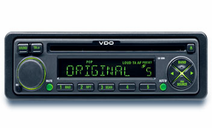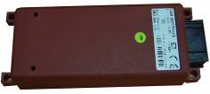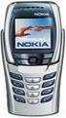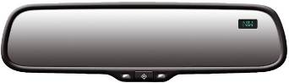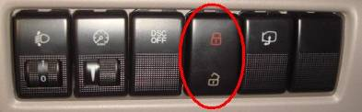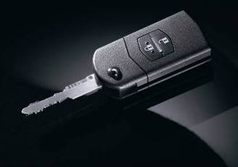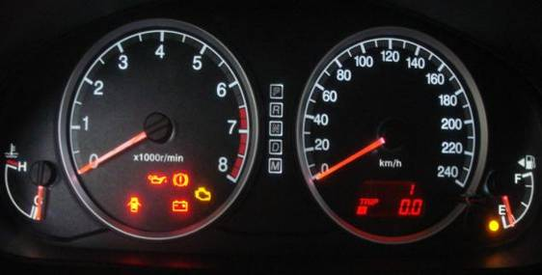
汽车供电、点火系统
043188857813

按键式中控锁开关：使用更方便

能够通过按键，可以控制四门及后备箱开启和关闭
遥控四门车窗自动升降：使用更方便

关闭后备箱和车门，常按¡°锁车键¡±，四门车窗玻璃关闭；
常按¡°开锁车键¡±，四门车窗玻璃关闭
增加人性化功能和配置，科技含量更高，提高使用方便性和行使安全性
车载蓝牙手机免提系统：使用更方便，行驶更安全

免提通话功能、挂断电话功能
末码重播功能、隐秘接听功能
满足了驾驶者在开车时无需手持电话、无需任何连线即可与亲朋好友尽情畅谈。由于它是全免提通话，故能解放双手，让驾驶者专心驾车，既安全又不违规，同时还避免了手机的电磁辐射。

白色仪表背景光：光线柔和不易疲劳，行驶更安全
产品变化带来的用户利益
产品方案——09款

